GUEST LECTURE ON TRANSGENDER RIGHTS AND STRUGGLES: 31-07-2022

Notice:
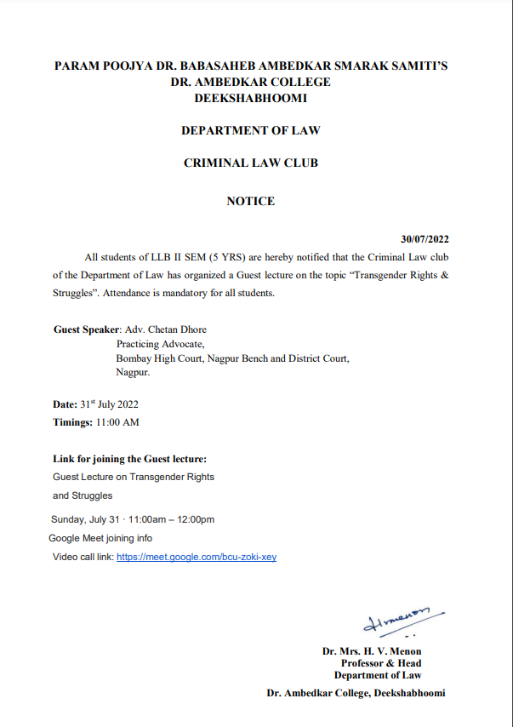

NAME OF THE PROGRAMME | Sensitization Workshop on the topic “Transgender rights and Struggles”
DATE AND DAY: | 31st July 2022
TIME: | 11.00 am to 12.30 pm
VENUE: | Virtual
ZOOM MEETING LINK: | https://meet.google.com/bcu-zoki-xey
PROGRAMME SUPERVISOR: | Dr. Sandhya P. Kalamdhad

On 31st July 2022, Department of Law through its Criminal Law Club organized a Sensitization Workshop on the topic “Transgender Rights & Struggles”. Approximately, 51 students of LLB ( 5 years course) joined the Workshop. Prof. Dr. H.V.Menon, Head of the Department of Law, Dr. Sandhya Kalamdhad, Co-ordinator of Criminal Law club, other Faculties joined the online Program through Zoom Meeting.
The Welcome address was given by Prof. Dr. H.V. Menon, Head of the Department of Law where she expressed the gratitude to the Resource person for sharing his knowledge and also emphasised the Importance of organizing such kind of sensitization programs by Criminal law Club for the Law students.
After the welcome address, Ms. Sarika Kamdi introduced the Resourse person. Adv. Chetan Dhore sensitized the students on a very important and contemporary issue of Transgender. By explaining the recent law on the subject, he elaborated some lacunas in the existing law. He cited important judgments of the Hon’ble Supreme Court to sensitize the students towards third gender. He emphasised upon that why and how law students should bear the responsibility to create awareness amongst the masses in regard to issues like this. It was indeed worth listening programme. Students were not only enlightened but they were greatly influenced by the speaker because of his unique style of dealing with this very sensitive issue. Coordinator of the club, Dr. Sandhya Kalamdhad proposed the vote of the thanks.

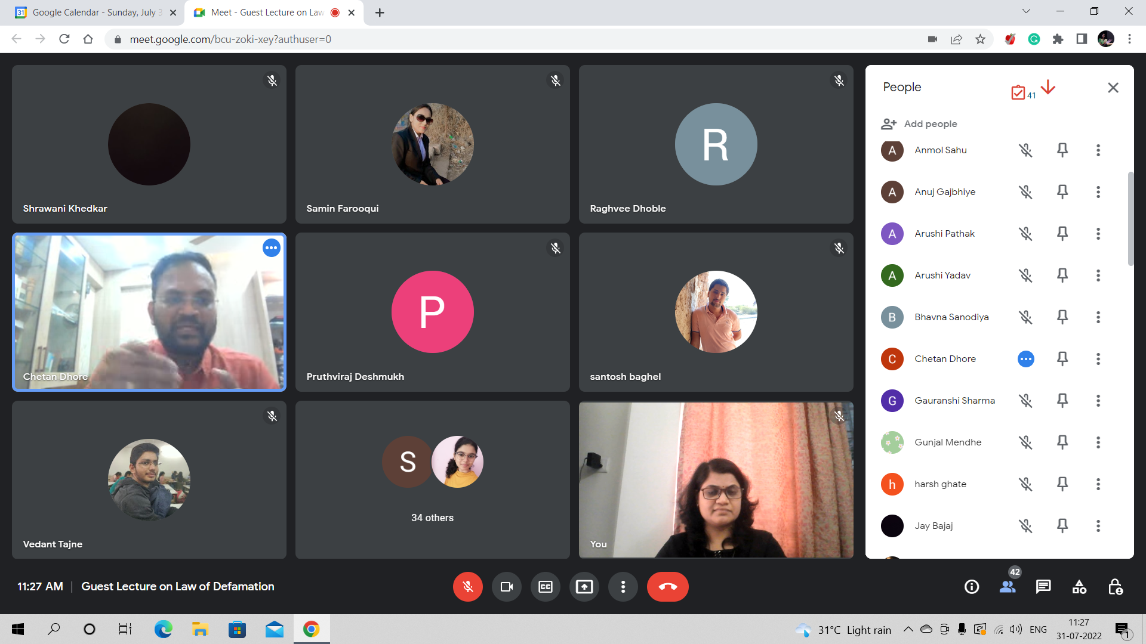

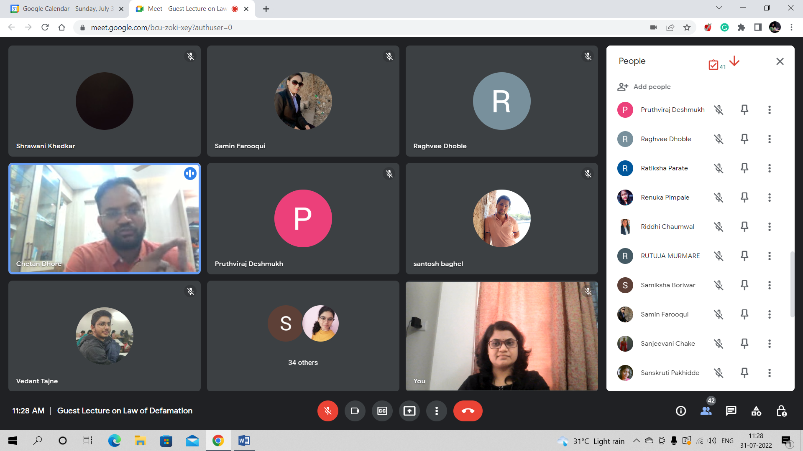
ADV. CHETAN DHORE ADDRESSING THE STUDENTS OF LAW
